# Object Oriented Programming Lab

**STUDENT MANAGEMENT SYSTEM**

**Project Report By**

**Syed Muhammad omer**

**Group Members:**

**Syed Muhammad Omer cs201144**

**Syed Ali Hassan cs201140**

**Muhammad hassanullah cs201086**

**Table of Contents**

1. Introduction

2. Scope

3. Module Description

4. Hardware/Software Requirements

5. Screen Shots

6. Architecture Diagram

# Introduction

|  |
| --- |
| **Student Management System** is a process of implementing all the activities of the student in a computerized automated way to fasten the performance. A Student Information System (SIS), also referred to as a Student Management System (SMS), Student Information Management System (SIMS) or Student Record System (SRS), is a software solution designed to help schools track and manage all their student data – everything from grades, attendance, behavioural information . |

# Scope

This system is aimed at total user-friendly as well as efficient management of varied tasks. These tasks may range from registering new students, managing fees payment, examination management to all the essential features necessary for making the administrative division of school effective.

# Module Description

The main purpose of Student Management System is to reduce the manual operation required to maintain all the records of Students. And also generates the various reports for analysis. The purpose of Student Management System is to perform Admission, Student Details, Marks, and About Fees etc.

**Software Requirements:**   
Apache NetBeans IDE12.3

Rx2xml JAR FOLDER

JDBC 3.34.0 JAR FILE

To View SQLite Database DB Browser

**Database table used:**

**CREATE TABLE "Admin" (**

**"Username" TEXT NOT NULL UNIQUE,**

**"Password" TEXT NOT NULL UNIQUE**

**, "AdminName" TEXT NOT NULL)**

**------------------------**

**CREATE TABLE "Course" (**

**"Semester" TEXT,**

**"CourseA" TEXT,**

**"ID_A" TEXT,**

**"CourseB" TEXT,**

**"ID_B" TEXT,**

**"CourseC" TEXT,**

**"ID_C" TEXT,**

**"CourseD" TEXT,**

**"ID_D" TEXT,**

**"CourseE" TEXT,**

**"ID_E" INTEGER**

**)**

**----------------------------------**

**CREATE TABLE "Grades" (**

**"Roll_Number" TEXT UNIQUE,**

**"GradeA" TEXT,**

**"GradeB" TEXT,**

**"GradeC" TEXT,**

**"GradeD" TEXT,**

**"GradeE" TEXT**

**)**

**------------------**

**CREATE TABLE "Notification" (**

**"notification" TEXT**

**)**

**---------------------**

**CREATE TABLE "QuizAwnser" (**

**"Roll_Number" TEXT,**

**"A1" TEXT,**

**"A2" TEXT,**

**"A3" TEXT,**

**"A4" TEXT,**

**"A5" TEXT**

**)**

**CREATE TABLE "QuizQuestion" (**

**"Semester" TEXT,**

**"Q1" TEXT,**

**"Q2" TEXT,**

**"Q3" TEXT,**

**"Q4" TEXT,**

**"Q5" TEXT,**

**"Q6" TEXT,**

**"Q7" TEXT,**

**"Q8" TEXT,**

**"Q9" TEXT,**

**"Q10" TEXT,**

**"Q11" TEXT,**

**"Q12" TEXT,**

**"Q13" TEXT,**

**"Q14" TEXT,**

**"Q15" TEXT**

**)**

**------------------------**

**CREATE TABLE "Student" (**

**"Username" TEXT NOT NULL UNIQUE,**

**"Password" TEXT NOT NULL UNIQUE,**

**"First_Name" TEXT,**

**"Last_Name" TEXT,**

**"Roll_Number" TEXT UNIQUE,**

**"Father_Name" TEXT,**

**"Batch_Number" TEXT,**

**"Semester" TEXT**

**)**

**---------------------------------**

**CREATE TABLE "StudentAttendence" (**

**"Roll_Number" TEXT,**

**"A1" TEXT,**

**"A2" TEXT,**

**"A3" TEXT,**

**"A4" TEXT,**

**"A5" TEXT**

**)**

**------------------------------------**

**CREATE TABLE "Teacher" (**

**"Username" TEXT NOT NULL UNIQUE,**

**"Password" TEXT NOT NULL UNIQUE,**

**"First_Name" TEXT NOT NULL,**

**"Last_Name" TEXT NOT NULL,**

**"Employee_ID" TEXT NOT NULL UNIQUE,**

**"Designation" TEXT NOT NULL,**

**"Course" TEXT NOT NULL**

**)**

**CREATE TABLE "login" (**

**"EMail" TEXT NOT NULL UNIQUE,**

**"Password" TEXT NOT NULL UNIQUE,**

**"Division" TEXT NOT NULL UNIQUE**

**)**

# Output Screen Shots

Login for student

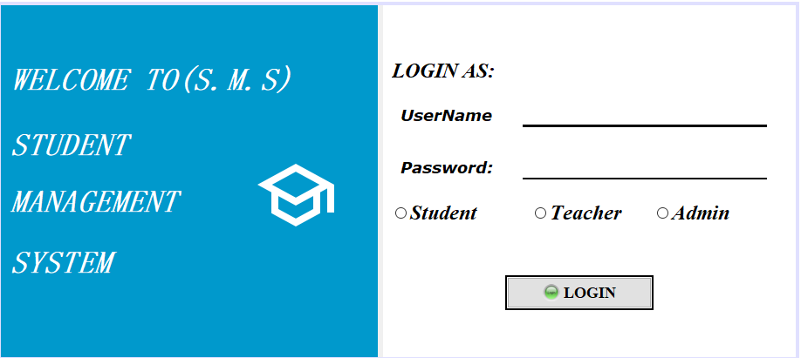

If login Input OR Password is incorrect

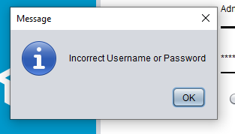

If Any of Field IS Selected Wrong

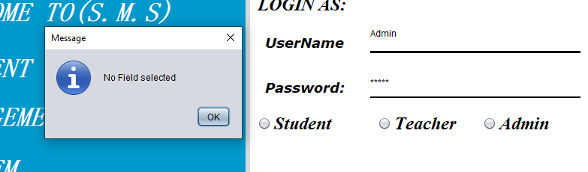

For Dashboard

Dashboard is able to navigate between

View profile, View Announcement, Attempt Quiz If Any, View Grades, Check Attendance.

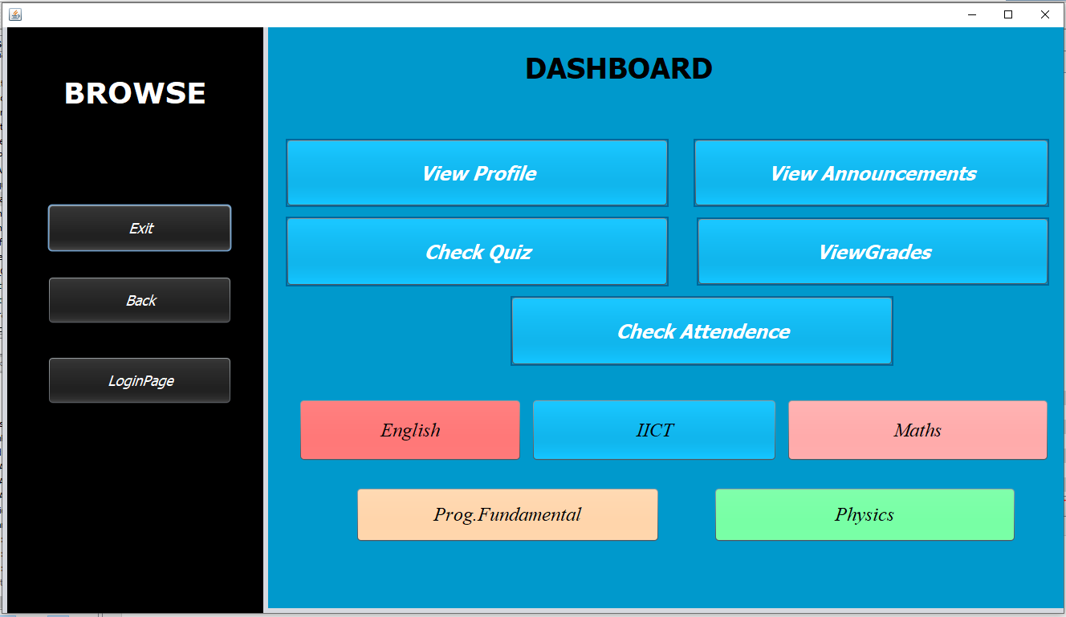

View Grades Added By Techer

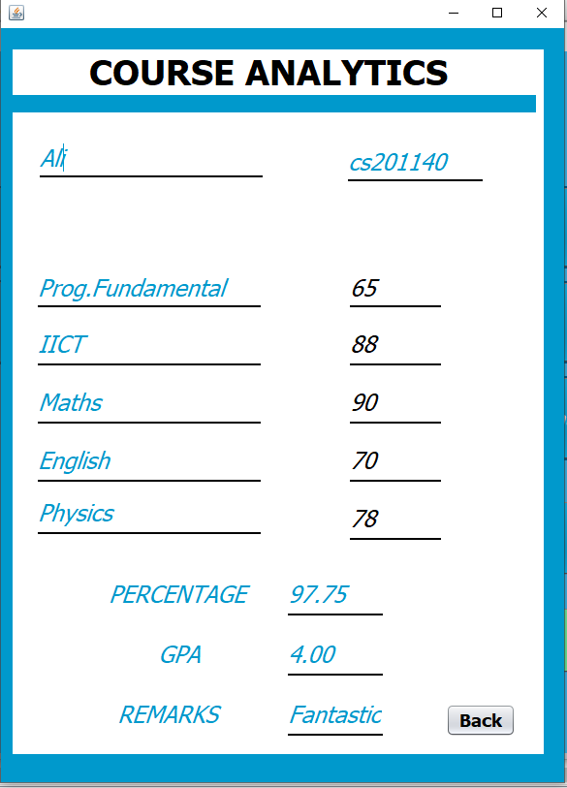

View Quiz Is Able To Randomly Provide Any Question By Question Bank Added By Teacher

In This Case Five Question Are Shown From Fifteen Question Provide By Teacher

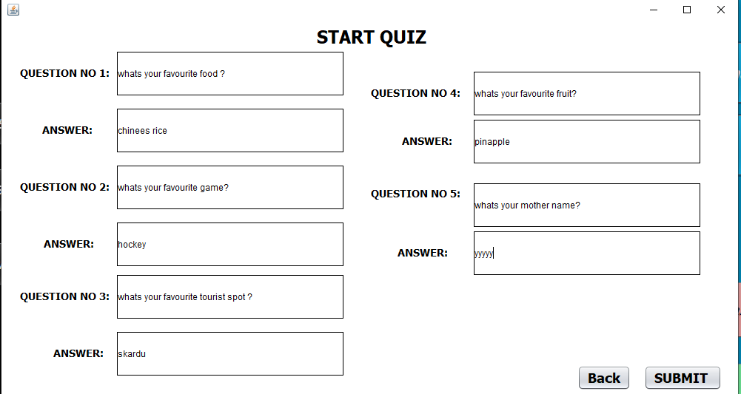

Answer Submitted By Individual User Are Saved Accordingly in Data Base

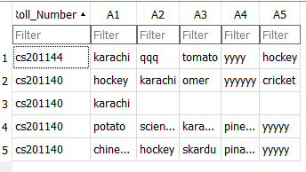

View Notification Page Is Abble To Show Notification Added By Teacher OF any Semester

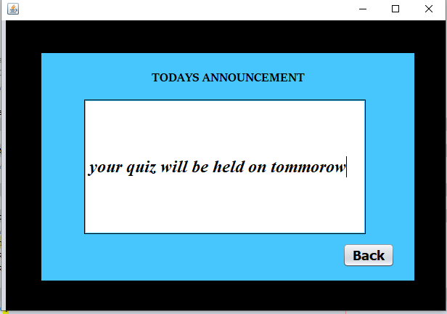

Database of announcement

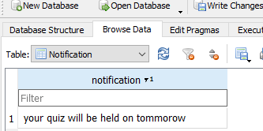

When teacher add any notification it will add on database and show in new announcement

Here is student profile that all information show from database and show in student profile

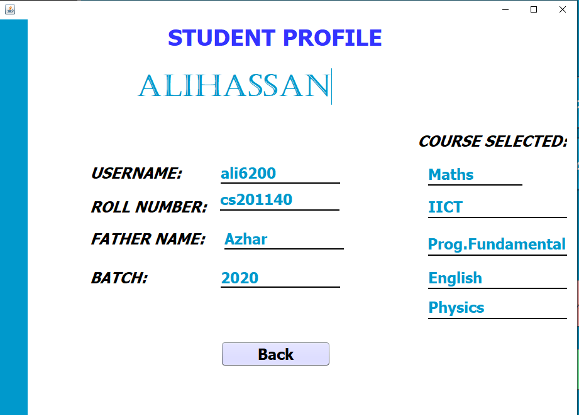

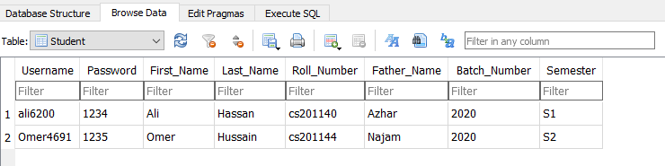

Here is attendance that display all your attendance of every subject from database

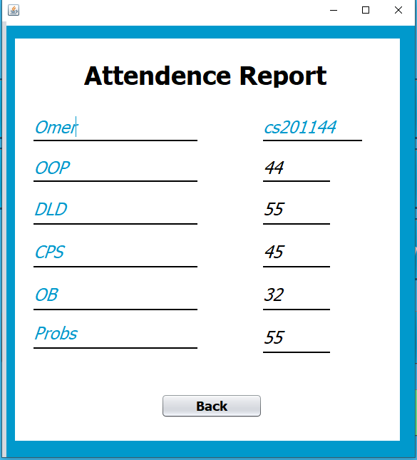

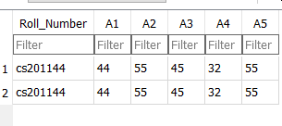

Login for admin:

When you login to the system first screen is admin dashboard that contain some feature given below.

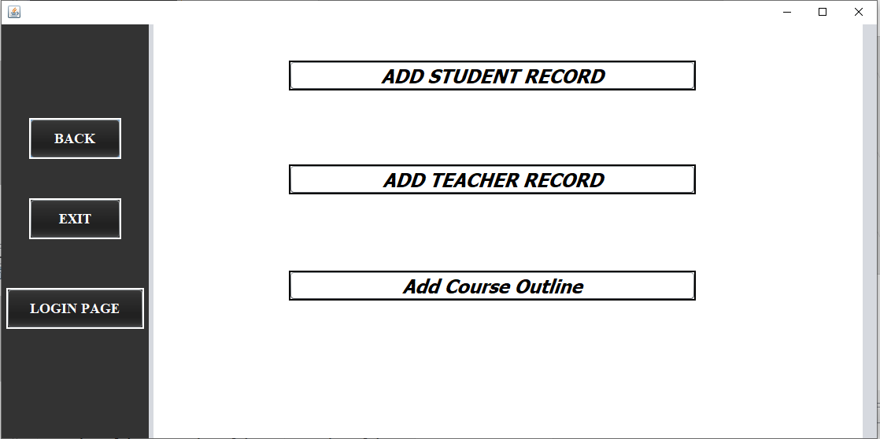

Add teacher record that has been saved in data base of teacher record

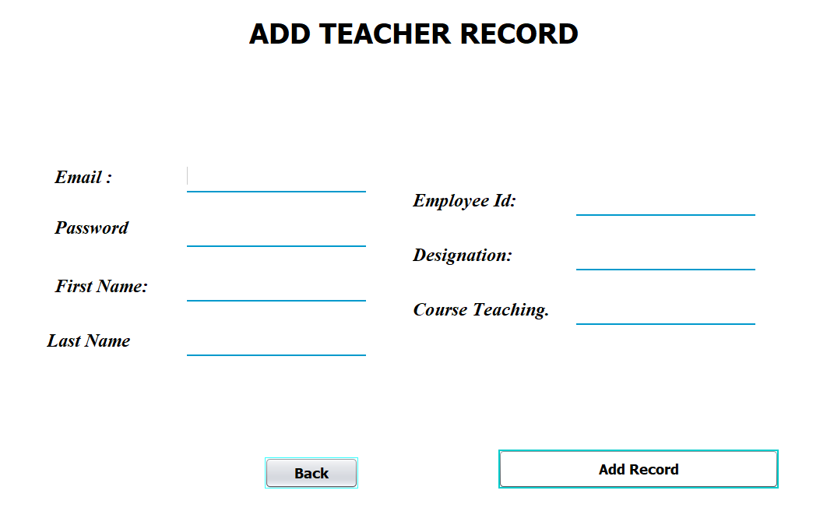

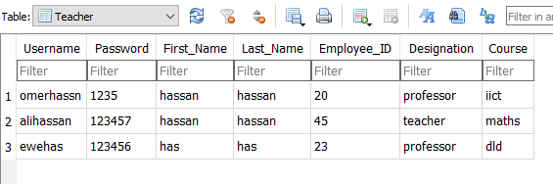

Add student record that has been saved in data base of student record

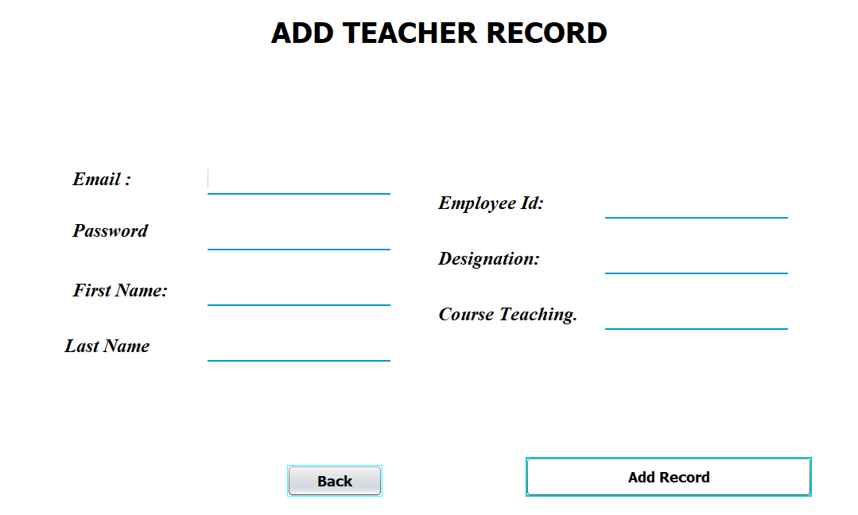

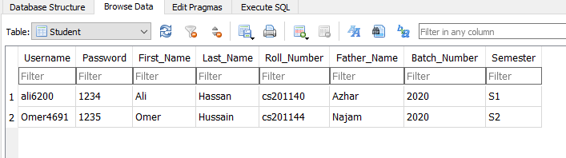

Add course outline feature is display all student course selection data

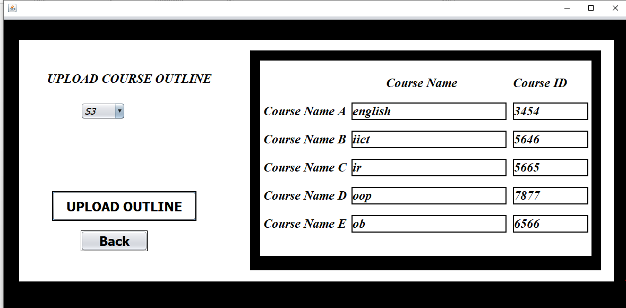

DATABASE:

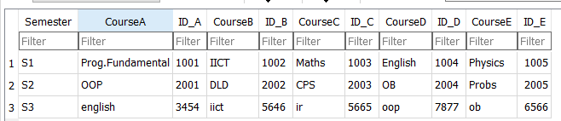

LIKE WISE ALL SUBJECT ARE ADDED INTO THEIR RESPECTIVE SEMESTER BY ADMIN

LOGIN FOR TEACHER:

When you login to the system of teacher here is the dashboard display below that contain some feature

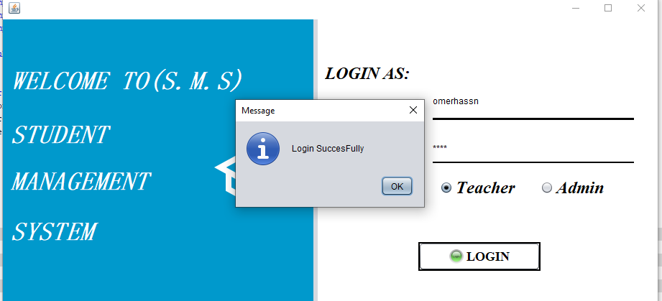

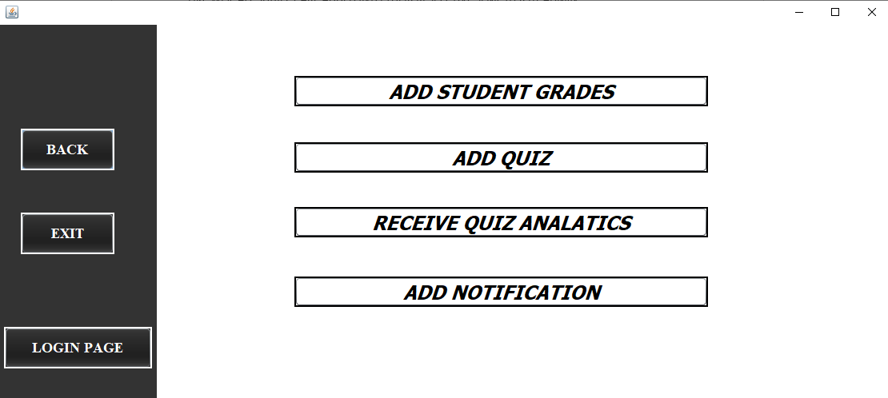

Add student grades function contain all grade updating that done by teacher

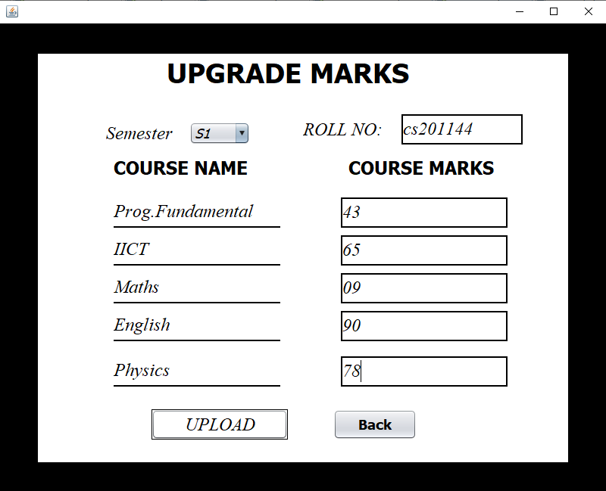

Database:

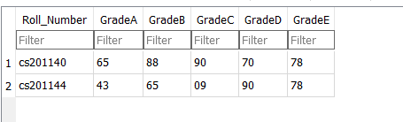

Add quiz fiction contain that teacher add quiz for all student

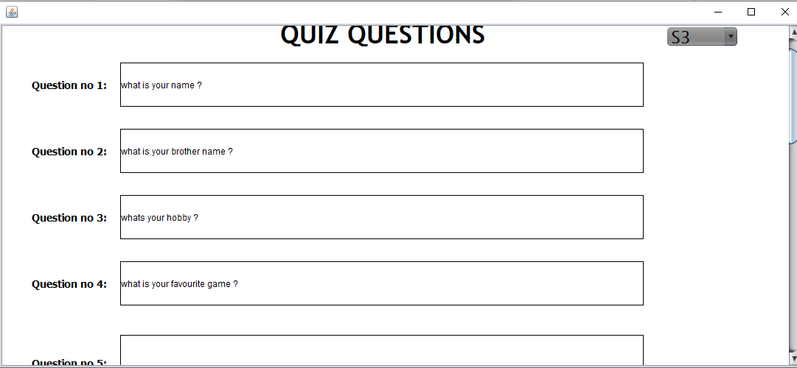

**Teacher add quiz and save in data base and these question shows to student in function view quiz**

**And all these questions are randomly generated question from question bank, student only fill 5 fill question and submit these answer that were save in data base**

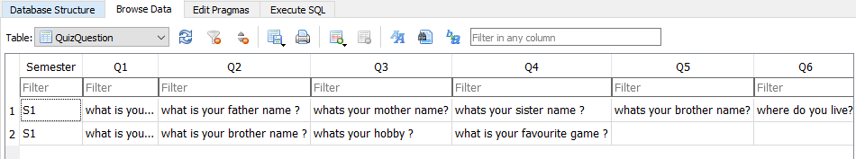

Notification:

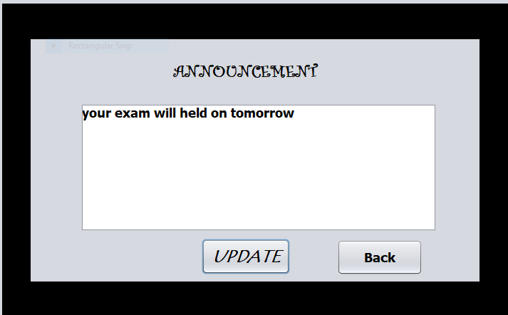

Database

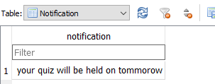

UML DIAGRAM :

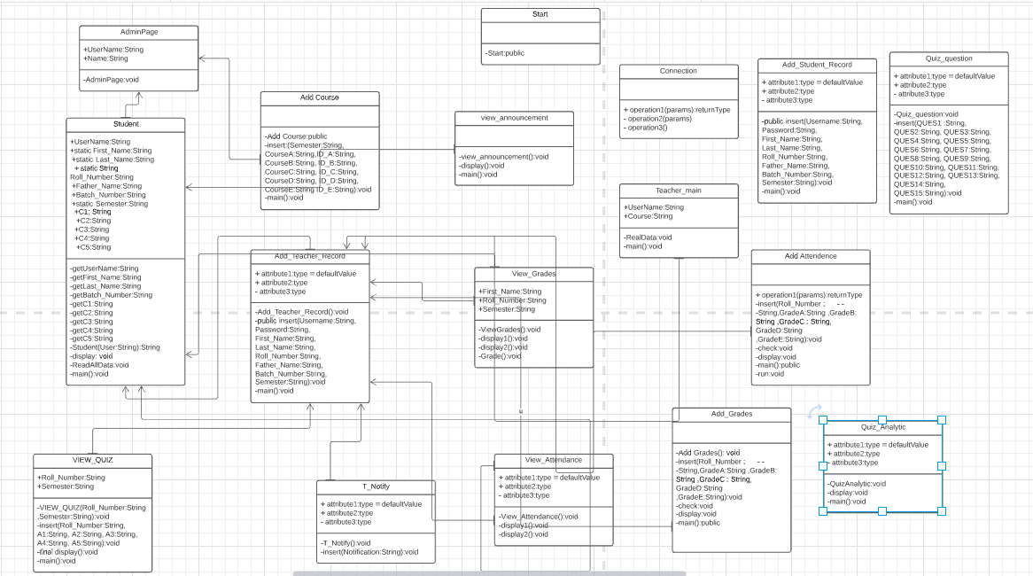

# Architecture Diagram

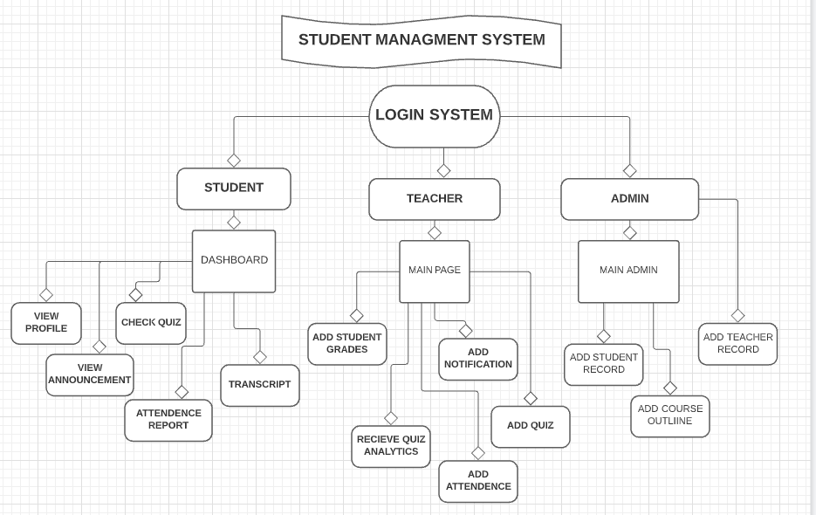

Presentation link:

https://drive.google.com/file/d/1CfnW2BybwhOi6PS9mI6WfthpL6AbOe0i/view?usp=sharing